21) In Figma, design a mobile app interface that prioritizes user connectivity and convenience. Highlight key elements.

Aim:
To design a mobile app interface that prioritizes user connectivity and convenience. Highlight key elements.

Procedure:
- Create a file
- Add The First Frame
- Add Shapes
- Add Text
- Create The Second Frame
- Add Prototyping
Step By Step Procedure :

Interface Of Experiment


Menu Page:
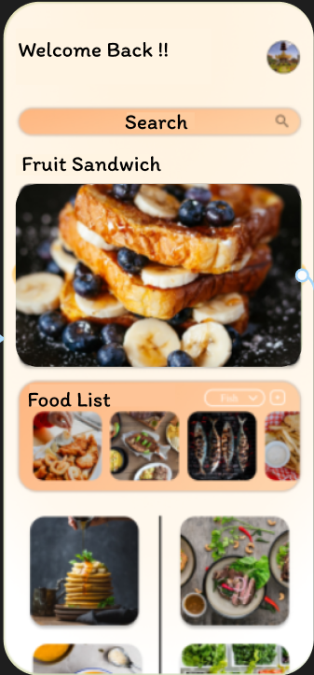
Final Step:
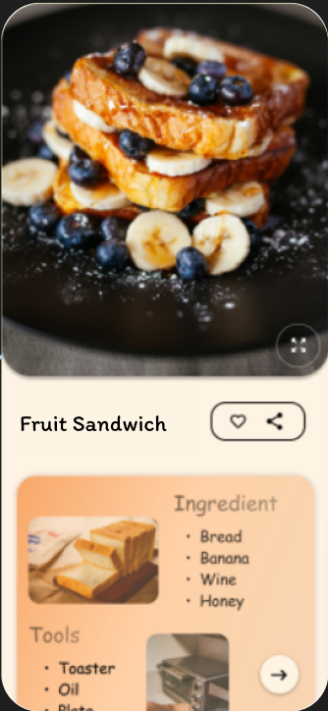

Prototype:
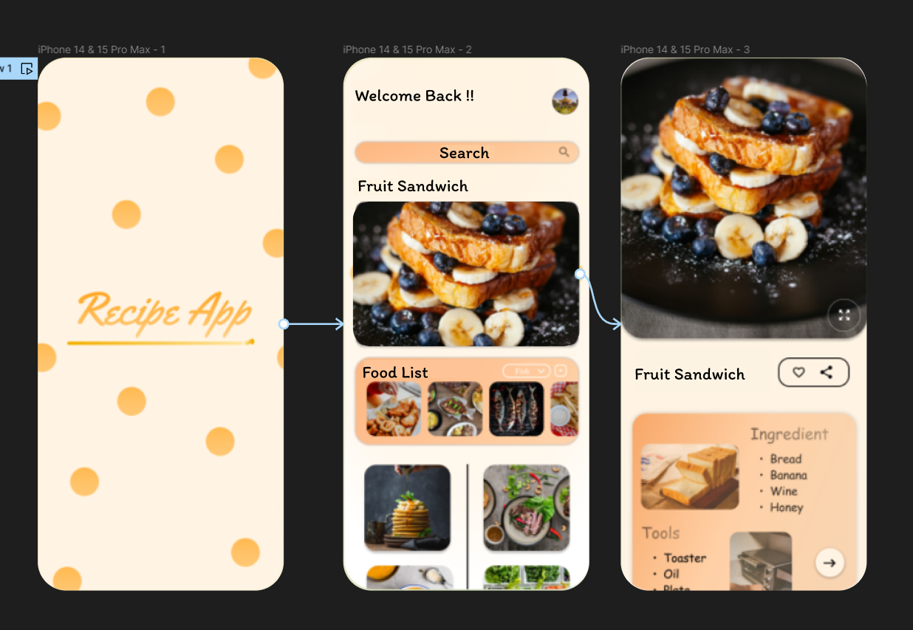
Result:
Hence the mobile app interface that prioritizes user connectivity created and executed successfully.

